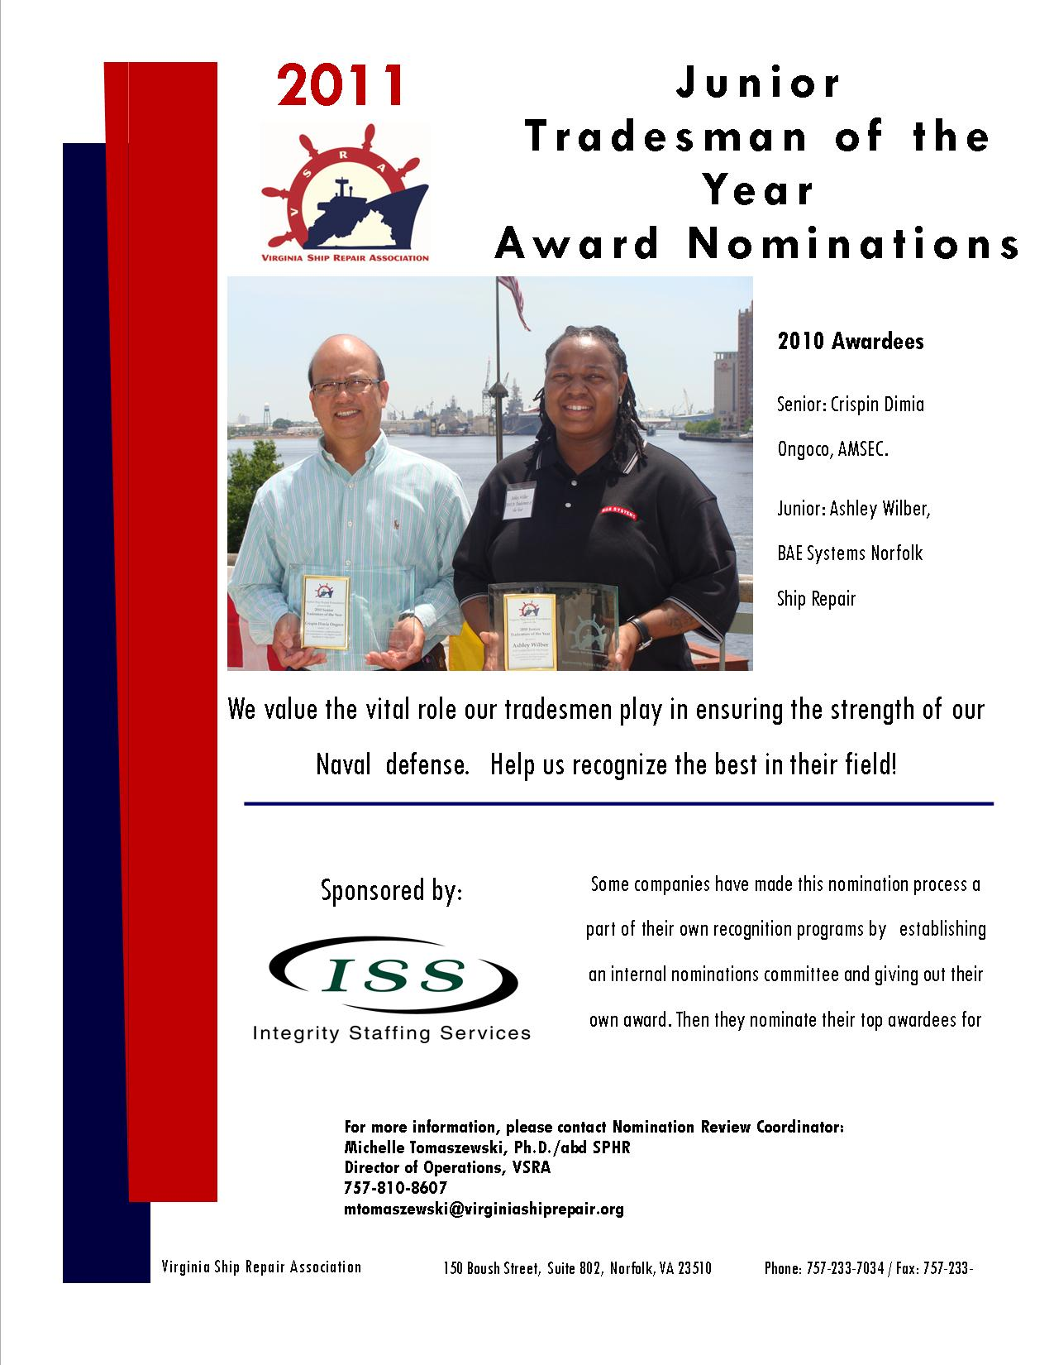

Virginia Ship Repair Foundation
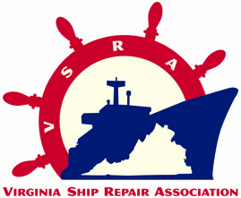
2011 JUNIOR TRADESMAN OF THE YEAR
(Less than five years in trade)
NOMINATION FORM
Only ONE Jr. Nominee per company. INCOMPLETE NOMINATIONS WILL NOT BE CONSIDERED.
Company Submitting Nomination: ________________________________ VSRA Member? YES___ NO___
Nominee’s Name: __________________________________________________________________
Nominee’s Trade Area: _________________________________ Less than 5 years in trade? YES___ NO___
Please list the last three employments with company name, job title, and duration of employment:
 | Company | Job Title | Duration of Employment
1.
2.
3.
Nominee’s Current Job Title: ________________________________________________________________
Nominee’s Telephone Number: _______________________________________________________
Nominator’s Name: ________________________________________________________________
Nominator’s Job Title: ______________________________________________________________
Nominator’s Telephone Number: ________________________ Email: ______________________________

You may submit your nomination in one of three ways: email, fax, or mail. Send to: Sylvia Bell at sbell@VirginiaShipRepair.org; fax 757.233.7035 or mail: 150 W. Boush Street, Suite 802 Norfolk, VA 23510. Please submit your typewritten nomination entry, along with this form by Friday April 29, 2011 at 5:00 p.m. NO EXTENSIONS will be made on the deadline! If you have any questions please contact the Nomination Review Coordinator: Michelle Tomaszewski at mtomaszewski@VirginiaShipRepair.org
- Please COMMENT on performance for each standard.

1. Demonstrates proficiency in area of expertise.
2. Consistently performs at the highest level of quality.
3. Consistently shares expertise with less experienced co-workers.
4. Mentors less experienced workers on career development plans.
5. Shares feedback on improvements with leadership.
6. Seeks training and improvement opportunities to enhance trade and operational expertise.
7. Maintains an exemplary safety record.
8. Instills safe working practices in co-workers/team.

CRITERION I. PROFESSIONAL REPRESENTATION OF THE SHIP REPAIR INDUSTRY
NOTE: This is the most important part of the scoring! You must describe how this nominee has EXCELLED in their field.
Briefly describe how the nominee demonstrates proficiency and excellence in his/her job:

Please respond with SPECIFIC EXAMPLES for each question.
Provide an example of creativity or innovation on the job:

Provide an example of leadership, mentorship or role modeling:

Provide an example of how the person has been recognized by the company, customers or other organizations:

Provide an example of Professional Development achievements (i.e. certifications, training, specialized skills)
Provide an example of Community Leadership Achievements

COMPANY AWARD AGREEMENT
- Per a decision by the Virginia Ship Repair Foundation, the awardees in this category will receive a VSRA embroidered jacket, $500.00 and awards memorabilia. In addition, the company submitting this nomination form agrees to give the nominee time to attend the VSRA General Membership Luncheon on Tuesday May 17, 2011 where the winner will be announced and if the employee is the winner one paid day off allowing them to attend the Annual National Maritime Day Luncheon. The company may decide, at their discretion, to allow the paid day off and allow the employee to attend the luncheon on a regularly scheduled work day. Nominees may bring one guest of their choosing to each of the luncheons; companies will cover additional seats at their expense.

Authorizing Company Representative Signature Date

